Date | 17/09/22
Team ID | PNT2022TMID48099
Project Name | Hazardous Area Monitoring for Industrial Plant  powered by IoT
Maximum Marks | 4marks
Ideation Phase
Brainstorm & Idea Prioritization Template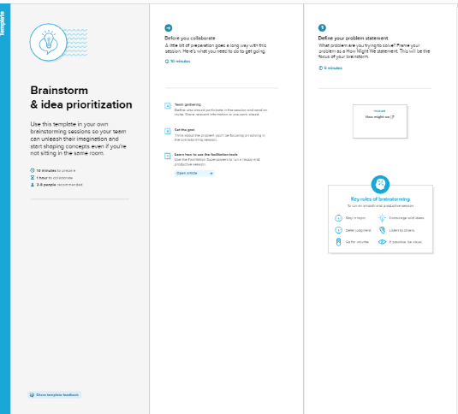
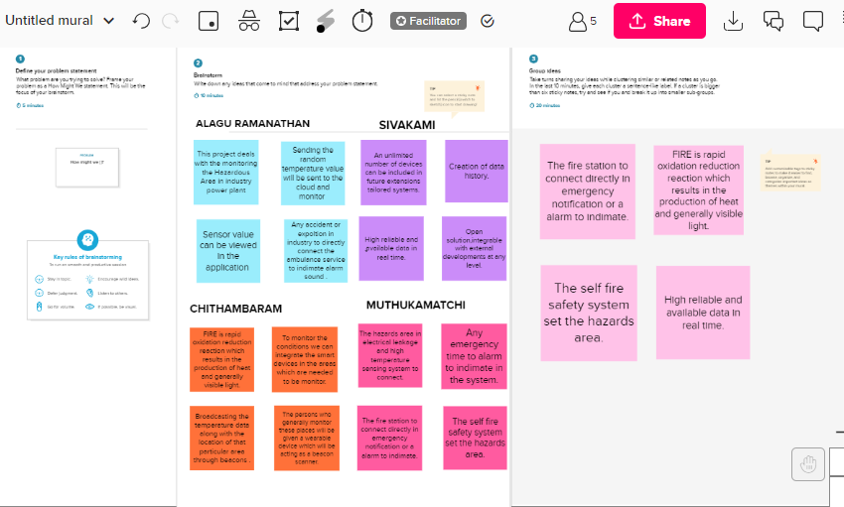
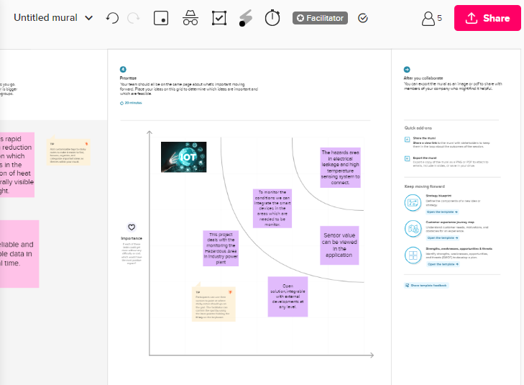
REFERENCE LINK: https://app.mural.co/invitation/mural/iotmakers7542/1663648369943?sender=u254a533787913ed14aa43587&key=c087dd12-0b36-46a8-bc55-4ec174b37f58

